10463321

ICT1521 ASSIGNMENT 4

DUE DATE : 09 / 08 /2021

**QUESTION 1**

|  |  |  |  |  |  |  |  |  |  |  |  |  |
| --- | --- | --- | --- | --- | --- | --- | --- | --- | --- | --- | --- | --- |
| |  |  | | --- | --- | | **Guideline** | **Yes / No** | | Regularly and thoroughly clean your hands with an alcohol based hand rub or wash them with soap and water | Yes | | Maintain at least 1 meter (3 feet) distance between yourself and others | Yes | | Wear a mask | Yes | | Avoid touching eyes, nose and mouth | Yes | | Make sure you, and the people around you, follow good respiratory hygiene | Yes |   **Signed by**  **Student Name : Karabo Maboka**  **Student signature :**  **Date :**  **Business owner / representative name : Luyanda Mbalana**  **Business Owner / representative Signature :**  **Date :** |

**Question 2**

LTI Tech Group (Pty)Ltd is an IT start up company that specializes in web development. It is based in Johannesburg. They build beautiful websites that are professional in design and superior in quality. Their websites focus on cultivating effective marketing tools. Marketing tools that create leads and ultimately convert leads into clients. They are an inspiring team that push passion into each and every project, start up or corporate giant. Within the digital agency world things move fast and revel in keeping up with, and surpassing the industry standard. On their monthly basis they do extensive research. Making sure that their clients are also running ahead of the pack.

**Question 3**

ER DIAGRAM for the databse

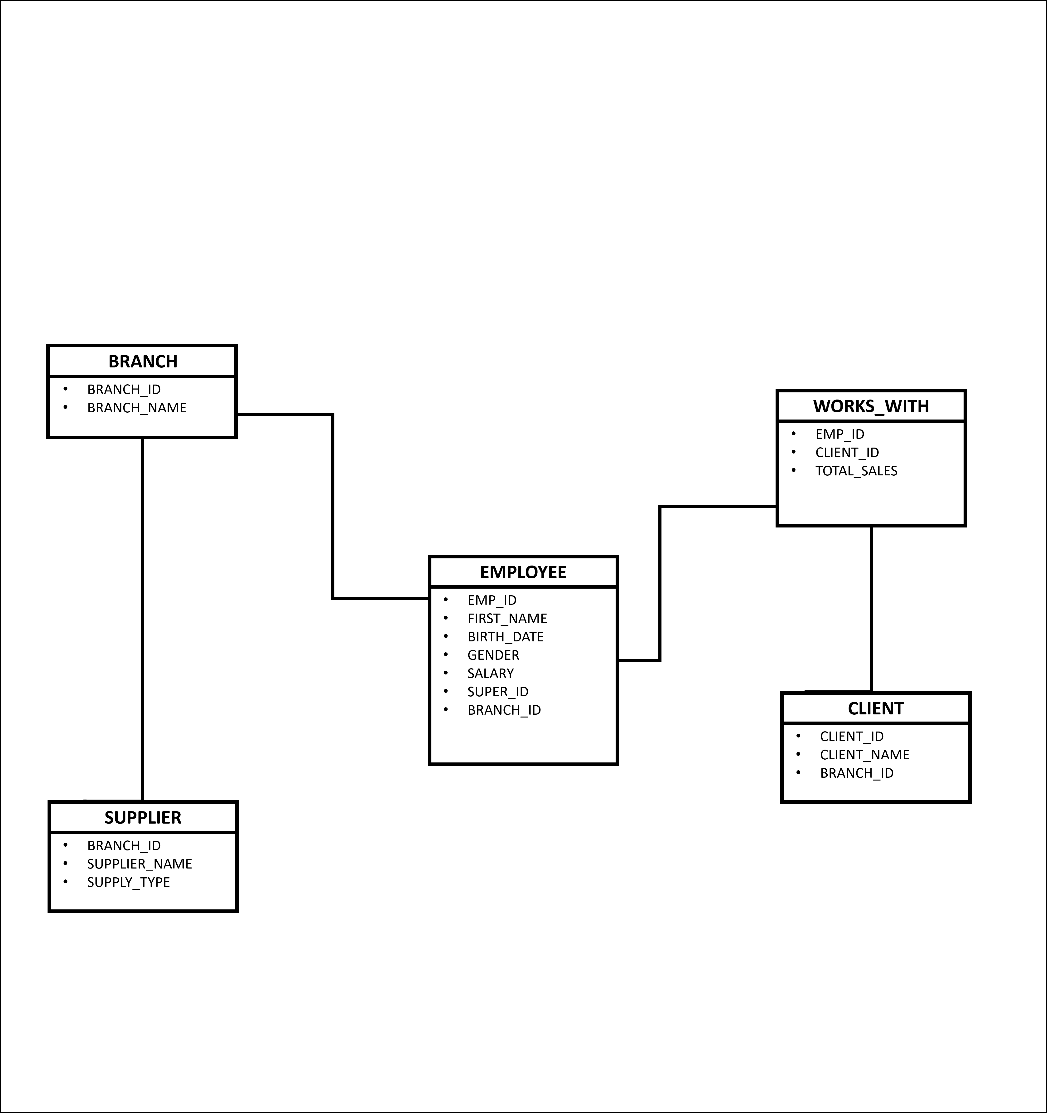

**Question 4**